


York
,
Bootham

Centre Handbook

2026

Contents

Contents ..................................................................................................................................................................... 2
Summary .................................................................................................................................................................... 3
The Centre ...................................................................................................................................................................4
Location ...................................................................................................................................................................... 5
Airport Transfers ............................................................................................................................................................................................ 5
Local Amenities ......................................................................................................................................................... 7
Accommodation ........................................................................................................................................................ 9
Room Allocation ........................................................................................................................................................................................... 9
Housekeeping ................................................................................................................................................................................................ 9
Key Loss ............................................................................................................................................................................................................ 9
Deposits ........................................................................................................................................................................................................... 9
Homestay Accommodation ………………………………………………………………………………………………………………………………. 10
Meals ........................................................................................................................................................................ 11
Meal times .................................................................................................................................................................................................... 12
Security .................................................................................................................................................................... 13
Safety ....................................................................................................................................................................... 13
Teaching ................................................................................................................................................................... 14
Placement tests .......................................................................................................................................................................................... 14
Programme .............................................................................................................................................................. 15
A typical day for students ...................................................................................................................................... 16
York, Bootham Sample Programme - Summer 2026 .......................................................................................... 17
Facilities .................................................................................................................................................................... 18
Evening entertainment ........................................................................................................................................... 19

Thank you very much for your interest in our centre in York, Bootham. We hope you find everything you need in the following pages but if you have any questions or specific requests then please get in touch with us at Head Office on 0044 1244 577995.
The contents of this handbook are updated regularly. The latest version will be sent before your arrival.
We look forward to a successful summer 2026 at Bootham.

Summary

Amazing city centre location
Boarding School
Swimming Pool
Intensive English
Performing Arts
Football
Short Transfers

The Centre

Bootham School is a traditional English private boarding school in the centre of York. It is a closed urban campus 6 minutes’ walk from the city centre.

It is a closed site with high security; there is CCTV on campus and the buildings have coded doors for access, the entrance gate is locked overnight and there is an on-site security guard from 8am until 10pm.

On campus, there are grass areas where students can take part in sports and activities.

In this centre, we accept students travelling in a group from 8 - 17 years old.

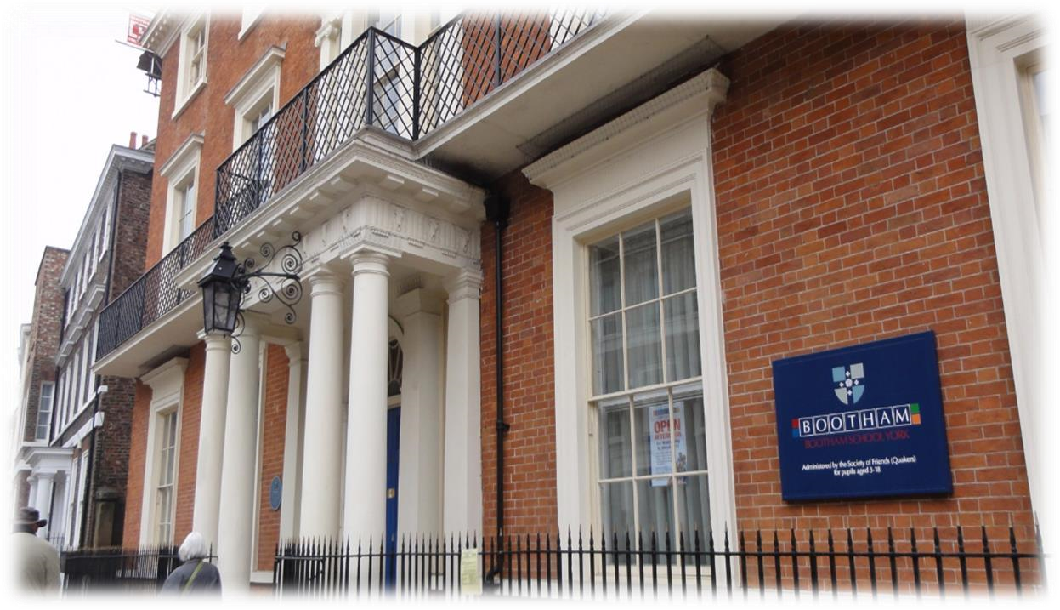

Location

BOOTHAM SCHOOL, YORK, YO30 7BU

Telephone Number - +44 (0) 1904 623261

Population- 200,000

It is a short distance to the city centre from Bootham School - approximately 0.3 miles (6 minutes’ walk)
York is undoubtedly one of the most beautiful cities in the UK, known for its rich history and heritage. It is to be found 40km to the east of Leeds and 40km from the east coast of England. The city has a proud Roman and Viking heritage which is still in evidence today. With a population of 200,000, York is big enough to feel lively, but small enough to be friendly and easy to explore on foot. York is regularly voted one of the best places to live and visit in the UK.

Airport Transfers:
Manchester: 1 hour 40 minutes
Leeds Bradford: 55 minutes London Heathrow: 3 hours 45 minutes
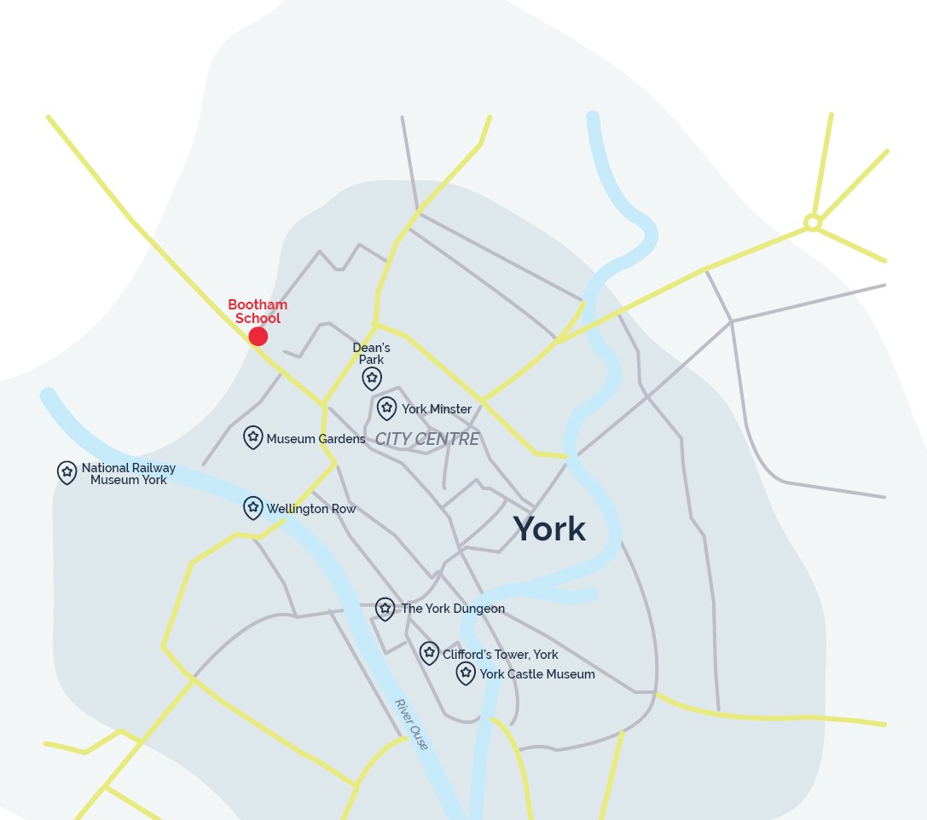
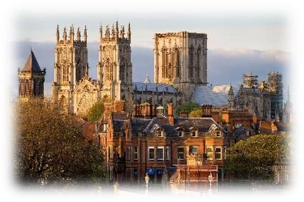

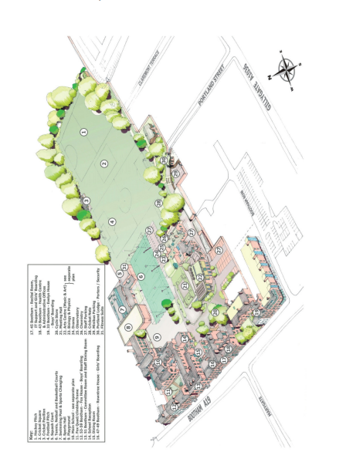

Local Amenities

Post Office
BOOTHAM SCHOOL, YORK, YO30 7BU
Telephone Number - +44 (0) 1904 623261
Population- 200,000
It is a short distance to the city centre from Bootham School - approximately 0.3 miles (6 minutes’ walk)

Supermarket
Sainsbury’s Local
Address: 31 Bootham, York, YO30 7BT (358ft / 1-minute walk)

ATM
Sainsbury’s Local
Address: 31 Bootham, York, YO30 7BT (358ft / 1-minute walk)

Chemist
Cohens
Address: 22 Gillygate, York, YO31 7EQ (0.2 miles / 4 minutes’ walk)

Hospital Hospital:
York District Hospital
Address: Wigginton Road, York, YO31 8HE (0.7 miles / 14 minutes’ walk)

Doctors Doctors:
NHS walk in medical centre at the York District Hospital.
*N.B.If a student is ill and requires a doctor, then a Group Leader and a UKLC staff member will take the student to the NHS medical centre at York District Hospital. The student will be required to fill out a temporary patient form and will be seen on the same day.*

Dentist
Aldwark Dental Practice
Address: 60-62 Aldwark, York, YO1 7BU (0.5 miles /11 minutes’ walk)

Bus Stops
Turn right out of the school and they are approximately 100 meters away. There are frequent buses that run to the train station and neighbouring towns.

Train Stations
York Railway Station
Address: Station Road, York, YO24 1AB for frequent, fast rail links to London and major cities in the UK. 0.6 miles (13 minutes’ walk)

Taxi Companies
659 Taxis: 01904 659659
Fleetways Taxis: 01904 365365

Coffee Shops
Brew and Brownie
A stylish café open 7 days a week, serving wonderful coffee and great quality breakfast or lunch.
Address: 5 Museum Street, York, Y01 7DT Walking distance from Bootham: 0.3 Miles (5-minute walk)

Perky Peacock Coffee Shop
Serving light lunches with the fine products from some of York’s best artisan producers.
Address: 72 Gillygate, York, YO31 7EQ Walking distance from Bootham: 0.2 miles (4 minutes’ walk)

Restaurants
Thomas’ of York
Thomas’ pub and kitchen has a typical British food menu in York.
Address: Museum St, York, YO1 7DT Walking distance from Bootham: 0.3 miles (7 minutes’ walk)
Hole in the Wall
Traditional, red brick venue with ales and classic pub food.
Address: York, YO1 7EH Walking distance from Bootham: 0.2 miles (3 minutes’ walk)

Mamma Mia
Mamma Mia serves authentic Italian food.
Address: 20 Gillygate, York, YO31 7EQ Walking distance from Bootham: 0.2 miles (4 minutes’ walk)

Residential Accommodation

The school has two residential houses with single, twin, triple and multi-bedded rooms and shared shower and toilet facilities. Each house has its own common room with TV. The houses are called Rowntree and Fox.

The rooms in Rowntree are made up of 4 singles, 8 twins, 3 triples, 3 Quads, 1 Quint and 1 room of six. There are shared bathrooms with a ratio of 1:5 with 14 showers in total. There are 6 kitchens and 1 common room in this house. All rooms in Rowntree are in corridors.

The rooms in Fox are made up of 7 singles, 9 twins, 6 triples, and 8 quad rooms. There is a total of 17 showers and 1 bath making a bathroom ratio of 1:5. There are 3 kitchens and 1 common room in this house. All rooms in Fox are in corridors.

There are also two additional residential houses we will be using, which are a short 5 minute walk from the school. The houses are located on the same road as Bootham school. The houses are called Manor and Dronfield.

Manor is made up of single, twin, triple and quad rooms. This house has a bathroom ratio of 1:4 and there is 1 kitchen and 2 common rooms in this house.

Dronfield is made up of single, twin and triple rooms. This house has a bathroom ratio of 1:4 and there is 1 kitchen and 1 common room in this house.

Room Allocation
We divide the students up according to their age, gender and group where possible. We take into consideration any specific requests, i.e. friends who want to be close to each other. Group Leaders will stay in the same house as their students. Room allocation is normally done on arrival. If you would like any further information on this, please contact us.

Housekeeping
Bedding is changed once a week. Bedrooms and bathrooms are cleaned 6 times a week. Bins will be emptied daily. All bedding is provided but towels are no provided.

There are washing machine and tumble dry facilities located in Rowntree house that are coin operated. It costs £1.00 per wash and students must provide their own washing powder.

Keys
This centre does not provide keys. There are key codes for each accommodation.

Deposits
We will ask each student for a deposit of €25/£25 on arrival. We will check their rooms before they arrive and before they leave and return the money if everything is in order. If there is damage to the houses and nobody admits fault, we will ask everyone in the house to share the cost.

Homestay Accommodation
Every host accommodation is different and our local organisers of homestay provision have endeavoured to provide accommodation that is of a good standard. Most homes in the UK are typically made from brick construction, with double glazed windows and usually a pitched tiled roof. The average home normally consists of a living room, kitchen/dining room, three bedrooms and a bathroom.
In addition, most homes will have an outside garden space in which to relax and enjoy the British sunshine. Sometimes your students will be the only guest, but some homestays have two, three and occasionally four students in their house. These can be students from the same group or the same nationality or a different nationality, depending upon the requests of your students.
Your students may have their own room or in some cases may be in a shared room, furnished with a bed, storage space. Students will be able to use a desk or table in the room/the house to do your homework.

Housekeeping
All homes are checked and assessed by our local organisers and must meet their exacting high standards. Our local organisers of homestay provision ensure that the houses we use are clean and tidy. For the short time that students are staying, they are a member of the household and it would be nice of them to offer to do some small tasks, e.g. set or clear the table and remember to tidy up after themselves.
Bed Linen will be provided by the host family. Students should bring their own towels.
Laundry during a homestay can differ from one host to another. Some hosts may offer to do a reasonable amount of laundry for your students and others may allow your students to do their own laundry. This may depend on the age of the students, i.e older teenagers might be expected to do their own.

Meals
Breakfast and evening meals will be with your hosts. During mini-stay courses throughout the year students will usually have packed lunches from their hosts. Mealtimes will usually be agreed with the hosts. Because Britain is a multi-cultural country our food tends to be varied. Breakfast usually consists of cereal or toast and a hot drink, lunch is often something light such as a sandwich or a salad and the evening meal, usually eaten around 6pm, is the largest meal of the day and can consist of meat, fish, vegetables, with either pasta, rice or potatoes, depending on the hosts.
Please note – there is an additional cost for students with special dietary requirements staying in homestay.

Getting to and from school:
On the first day the Hosts will either drive, walk or take the bus with the students to the meeting point and show them the correct route. When they get to the centre they will meet the UKLC team and sign in for the day. At the end of the day the students meet at a designated point where the hosts will arrive to pick them up. After the first day, and once the students are happy and familiar with the route, they will make their own way to the meeting point and always sign in upon arrival with the UKLC team. In some cases, the Hosts will continue to accompany the students if, for example, it is on their way to work. If students are aged under 13 then the hosts will be asked to accompany them to and from school on ALL occasions

Meals

When the students are on campus, they will eat their meals in the dining hall on site. When they are out on full day excursions, they will be provided with packed lunches.
Cooked breakfast is supplied once a week.

Meal times
Breakfast: 08:00 – 08.45
Lunch: 12:30 - 13:30
Dinner: 18:00 – 18.45

If we are aware in advance, we can advise the catering staff of any dietary requirements or allergies and the canteen staff can cater to these.
*Mealtimes are subject to change

York, Bootham – Sample Menu
Monday Tuesday Wednesday Thursday Friday Saturday Sunday

Breakfast | Selection of  Cereals,  Yoghurts, Bread to Toast &Hot  Choices including  Bacon,  Scrambled Egg,  Baked Beans,  Flat Fried  Mushrooms &  Roast Tomatoes | Selection of  Cereals,  Yoghurts, Bread to Toast,  Croissants, Pain  Au Chocolat and a hot choice of  Kedgeree | Selection of  Cereals,  Yoghurts, Bread to Toast, &Hot  Choices including Bacon,  Poached Egg,  Baked Beans,  Flat Fried  Mushrooms &  Roast Tomatoes | Selection of  Cereals,  Yoghurts, Bread to Toast & Hot  Choices including  Sausages, Fried  Eggs, Baked  Beans, Potato  Waffles & Plum Tomatoes | Selection of  Cereals,  Yoghurts, Bread to Toast, & Hot  Choices including  Bacon,  Scrambled Egg, Baked Beans.  Croissants &  Pain Au  Chocolat | Selection of  Cereals,  Yoghurts,  Bread to  Toast & Hot  Choices including  Bacon,  Scrambled  Egg, Baked  Beans, Flat  Fried  Mushrooms &  Roast  Tomatoes | Selection of  Cereals,  Yoghurts, Bread to Toast, & Hot  Choices including  Bacon,  Scrambled Egg, Baked Beans.  Croissants &  Pain Au  Chocolat
Lunch  *(V)  Vegetarian option available | Aubergine  Parmigiana (V) Or  Chicken Korma,  Basmati &  Poppadums,  Cauliflower &  Chutneys Or  Fusilli Roasted  Tomato & Basil  Sauce with  Focaccia Slab  Mixed salads, Soups and  Filled Breads available | Stuffed Red (V)  Peppers with  Spinach,  Peppers, Rice &  Thyme  Or  Lamb Moussaka with Green  salad & Garlic  Bread  Or  Leek & Gruyere  Cheese Pastry  Tart  Mixed salads, Soups and  Filled Breads available | Mushroom  Stroganoff on  Brioche with  Parsley & Fresh  Salad (V)  Or  Roast Loin of  Pork, Yorkshire  Pudding, Roast  Potatoes,  Broccoli, Carrots  & Gravy Or  Roasted  Vegetable,  Garlic Bread &  Salad  Mixed salads,  Soups and Filled  Breads available | Beetroot &  Squash Frittata with Smoky  Mayonnaise (V)  Or  Cobbler with  Beef Mince,  Carrot & Sugar  Snap Peas  Or  Squash and  Sage Risotto  Mixed salads, Soups and  Filled Breads available | Spring  Vegetable  Paella (V)  Or  Breaded Plaice,  Poached Fish with New  Potatoes &  Peas, Tartare  Sauce  Or  Spinach &  Ricotta  Tortellini  Mixed salads, Soups and  Filled Breads available | Warm Duck  Salad with  Mango,  Beetroot and  Honey &  Orange  Dressing (V) Or  King Creole  Chicken served with  Wild Rice  Or  Pasta Shells with  Chickpeas,  Red Cabbage,  Garlic, Chilli & Olive Oil  Mixed salads, Soups and  Filled Breads available | Cannelloni  Or  Breaded Plaice  Goujons  Or  Cheese &  Onion Pastie  Selection of  Vegetables,  Potatoes &  Plain Pasta  Salad  Mixed salads, Soups and  Filled Breads available
Dinner  *(V) Vegetarian option available | King Prawn,  Spring Onion,  Ginger, Garlic,  Soya Bean,  Broccoli & Corn  Noodles  Or  Tomato &  Mozzarella  Calzone with  Fresh Green  Salad  Mixed salads and Filled  Breads available | Bootham  Buffett Meats, Fish, Pickles,  Salads, Breads  & Hot Potatoes  Mixed salads and Filled  Breads available | Roasted  Summer  Vegetable Tart  & Summer Salad  Minted Potatoes  Or  Yorkshire Beef  Meatballs in a  Mediterranean Sauce &  Linguine Pasta  Mixed salads and Filled  Breads available | Vegetable Kiev served with  Summer Green  Vegetables &  New Potatoes  Or  Slow cooked  Chicken, Rogan  Josh  Mixed salads and Filled  Breads available | Mushroom  Burgers & Blue Cheese with  Cos Lettuce,  Sauté Potato  Or  Katsu pork with  Sticky Rice &  Greens  Mixed salads and Filled  Breads available | Traybake  Sausages with  Pepper,  Onions, New  Potatoes,  Fennel &  Herbs with  Crusty Bread  Mixed salads and Filled  Breads available | Battered Fish with Tartare  Sauce  Or  Meat Balls in  Tomato Sauce  Mixed salads and Filled  Breads available
Pudding | A selection of seasonal cut  fruit,  Homemade  Yoghurt with  Fresh Fruit toppings,  Raisins and  Banana chips and Chocolate and Orange  Sponge with Custard | A selection of seasonal cut  fruit,  Homemade  Yoghurt with  Fresh Fruit toppings,  Raisins and  Banana chips and Summer  Fruit Jelly | A selection of seasonal cut  fruit,  Homemade  Yoghurt with  Fresh Fruit toppings, Raisins and Banana  chips and Apple,  Sultana &  Cinnamon  Crumble with Custard | A selection of seasonal cut  fruit,  Homemade  Yoghurt with  Fresh Fruit toppings,  Raisins and  Banana chips and Iced Lemon  Cake | A selection of seasonal cut  fruit,  Homemade  Yoghurt with  Fresh Fruit toppings,  Raisins and  Banana chips and a selection  of Mousses and  Compotes | A selection of seasonal cut  fruit,  Homemade  Yoghurt with  Fresh Fruit toppings,  Raisins and  Banana chips and  homemade  Gateaux | A selection of seasonal cut  fruit,  Homemade  Yoghurt with  Fresh Fruit toppings,  Raisins and  Banana chips and Summer  Fruit Jelly

Technology
Wi-Fi is available campus wide and is password protected. Being a private boarding school, the internet access is firewalled as per the boarding school regulations. However, it is at the Group Leader’s discretion whether they give these details to their students. Wi-fi will be switched off between 23:30 and 06:00.

Security

There is CCTV coverage on campus and the main gate is accessible via swipe card entry only overnight.

Emergency contacts: Each student will be given a wristband when they arrive, and this will have the following emergency telephone number printed on it: 0044 1244 567695. If you need to contact the centre in the event of an emergency please call this number and follow the options for the relevant centre, this will then put you through to the person on duty.

Certain basic guidelines are common to all centres and students. Students should:
- Never walk away alone!
- Never leave the residence without permission in the evening!
- Always make sure they have understood when and where the meeting point is whilst out on excursions!
- Always wear their identification lanyard and their UKLC wristband! *
*students found not wearing their lanyard or wristband will be fined £1

Safety

- Remember that there is a 24-hour emergency telephone number on the wristband (0044 1244 567695) and that the number for the emergency services (Ambulance/Police/Fire) in England is 999, or the single emergency number for the EU including the UK is 112 or you can call 101 to report a crime where you do not need an emergency response
- The police are there to help and protect and can be asked for assistance!
- Never respond to someone if you feel threatened, simply walk away!
- Always give your money to the UKLC management team to put in the safe and never to carry large amounts of cash around!
- Be careful crossing the road. Remember that in the UK we drive on the left!
- If you are ill or need a doctor, tell a member of UKLC staff immediately!
- Keep all windows closed when not in your bedrooms!

Insurance and valuables
Although all houses will be accessed via swipe cards, it is suggested that students try to avoid bringing very expensive items with them. If they are bringing valuables with them, it essential that they have sufficient insurance to cover any loss of damage as neither the centre nor the company can be held responsible if anything goes missing. The Centre Manager will have access to a safe if it is required.

Teaching

We know how important it is for each individual student to find their own path in language learning. We use a wide range of methods to engage and stimulate our students. This is why we have created a curriculum based on the students’ age, level and needs, structured into four different programmes:
FUN (ages 8-10)
Engaging lessons that offer a wide range of materials and activities specific for our young learners, making games into lessons and lessons into games. Available in levels A1-B1.

CONNECTION (ages 10-13)
Dynamic lessons covering a variety of topics and media, designed to engage students using tools native to the fast-paced world they are growing up in. Available in levels A1-C1.

ACTION (ages 13-16)
Lessons tailored for learners stepping into their teenage years. This programme focuses on activating students’ knowledge and competencies to balance developing a personal voice while contributing effectively to a team. Available in levels A1-C1.

PURPOSE (ages 16-18)

Lessons tailored for our students approaching adulthood, designed to kickstart their lives not only as maturing youths but also as forward-thinking global citizens. Available in levels A1-C2.
The Connection, Action, and Purpose programmes consist of three different lessons a day:

FOCUS ON LANGUAGE

These lessons aim to empower our students’ linguistic awareness and capabilities by working on all language skills (reading, writing, listening, speaking) and systems (grammar, phonology, lexis, discourse), as well as using materials relevant to exam preparation (KET, PET, FCE, CAE, TOEFL, IELTS, GESE).

FOCUS ON LEADERSHIP

This programme is designed to equip students with essential 21st-century skills, focusing on leadership development, communication and teamwork. Students build the confidence and competencies needed to grow into empowered young adults.

FOCUS ON CULTURE
These lessons combine CLIL and British culture, allowing students to use English to explore a range of disciplines, including art, literature, natural sciences, as well as the history and geography of the UK.

Placement tests
We offer classes at four levels, from elementary to advanced. Students take a placement test on their first day of classes to ensure they are placed at the correct level.

Once the tests have been marked, students won’t be told their score unless they specifically ask for it but will be placed into a class based on these results.

If students are not happy with their level, they can speak with the Course Director who will decide if it is necessary for the student to change levels.

We always try to split groups into different classes to mix nationalities, but this does depend on their levels and the numbers of students that we have on site.

We will provide all course materials including a journal and a pen.

Students are taught in class sizes up to 16.

Programme

All UKLC summer programmes include:

- 15 hours of English lessons
- Full board accommodation in residence
- Full programme of excursions, activities and evening entertainment
- 1 free leader for 15 students
- Placement test on arrival and End of Course Certificate

These are summaries of UKLC English Plus programmes** for Summer 2026 at York, Bootham.

English Plus Multi-Activity
The “typical” summer programme consisting of a wide variety of activities and sports. Sessions are structured and are coached by specialist staff. Sessions can include tennis, basketball, volleyball, swimming, photography workshops, dance, football, and drama etc. Students are moved through two or three activities on rotation in each session.

English Performing Arts*
During these sessions, students passionate about dancing, acting, or singing will immerse themselves in hands-on training designed to unleash their creative potential on any kind of stage. They will not only develop their talents but also experience the thrill of live performance, collaboration, and artistic expression.

English Plus Intensive English & Community Building*
Additional English lessons for those who really want to maximise their language learning during their stay in the UK. Based on UKLC's integral community-building approach, these additional lessons aim to help students develop an active role in the school as a thriving community, with its challenges, complexities and opportunity for collective growth. The Community Building lessons focus on how to empower students to work together to find possible solutions to these needs and issues by communicating with people on campus. Students create these projects that they are responsible for in order to improve these issues on campus.

English Plus Football*
For students who love football and want to play it every waking minute! Coaching sessions are led by qualified staff and aim to improve each student’s technical skills and abilities. It also aims to build on their understanding of match tactics and playing systems. There are regular matches and a weekly showpiece game.

*Students aged between 11 and 17 who are enrolled on Multi-Activity or English Plus courses will be divided by age for activities where numbers allow. Students can choose whether to enrol on the Multi-Activity or an English Plus course.
All students aged between 8 and 10 will be automatically enrolled on the multi activity programme.

**These programmes vary at each centre. A minimum of 10 students applies to each programme and each student will be asked to select a 1st and 2nd option before arrival which they will join for the duration for their stay. Students who do not choose in advance will join the standard English Plus Multi-Activity.

A typical day for students

08:00 – 08.45 | Breakfast
09:00 – 10:00 | Lesson 1
10:00 – 10:15 | Break
10:15 – 11:15 | Lesson 2
11:15 – 11:30 | Break
11:30 – 12:30 | Lesson 3
12:30 – 13:30 | Lunch
14:00 – 17:30 | Afternoon Activities
18:00– 18.45 | Dinner
20:00 – 22:00 | Evening Activities

York, Bootham Sample Programme - Summer 2026

Week 1 |  | Morning |  | Afternoon |  | Evening
 | Monday | Arrivals
 | Tuesday | English Test |  | Multi-Activity or  Chosen Programme |  | Message Disco
 | Wednesday | Lessons |  | York with York Dungeons |  | Around the World or Conversation Club
 | Thursday | Lessons |  | Multi-Activity or  Chosen Programme |  | Mini Olympics
 | Friday | Lessons |  | Leeds with Royal Armouries Museum |  | Horrible History or  Conversation Club
 | Saturday | Lessons |  | Multi-Activity or  Chosen Programme |  | Karaoke
 | Sunday | Manchester with Etihad Stadium Tour |  |  |  | Film Night
 | Monday | Free Time, Activities or Optional Excursion |  |  |  | Campus Monopoly
Wee  k 2 | Tuesday | Multi-Activity or  Chosen Programme |  | Lessons |  | Quiz Night or Conversation Club
 | Wednesday | York with National  Railway Museum |  | Lessons |  | Karaoke
 | Thursday | Multi-Activity or  Chosen Programme |  | Lessons |  | Paparazzi or Conversation Club
 | Friday | Castle Howard |  | Lessons |  | Talent Show
 | Saturday | Multi-Activity or Chosen Programme | Lessons |  | Film Night
 | Sunday | Whitby with Bark Endeavour |  |  |  | Leaving Disco
 | Monday | Departures

Please note: This is a sample programme and may be subject to change. It may also be necessary to operate a zig zag programme of morning / afternoon lessons.

Facilities

Sports facilities on site:
- Sports hall
- Heated indoor swimming pool
- Tennis courts
- Grass football pitches
- Volleyball pitch

Performing arts lessons will be held in the main hall.

Sports available at this centre can include - football, handball, basketball, rounders, volleyball, cricket, table tennis, tag rugby, indoor hockey, badminton & tennis.

Evening entertainment
The UK Language Courses staff plan fantastic activities to make sure the students enjoy their evenings. For example: discos, quizzes, fashion shows, blind date, sports tournaments etc. We ask Group Leaders to encourage students to participate as much as possible and to communicate any special ideas or requests from students.

Here are a few brief descriptions of just some of our activities for students to join in on:

Around the World
Consists of a number of different stations based on activities from different countries. One staff member will be placed at each activity station. They will each represent a country and have to create an activity related to that country (for example: New Zealand – The Haka). Students will be divided into groups and given a time for each station. Students will visit each station.

Oscars Night
Involves students watching a number of scenes from selected films. They will have the chance to re-enact a famous selected scene. Creating their own script, which must be in English and costumes (out of various given equipment). Scenes will be shown on a big screen for everyone to watch. Awards will be given by UKLC staff for the best reproduction.

Speed Dating
Enables students from mixed nationalities to socialise and get to know each other whilst improving their spoken English. Students will have a short period of time to have a conversation on their interests, hobbies etc. Once the given time finishes they will move to another student and begin the same process again.

Talent Show
Gives students the opportunity to perform talents such as singing, dancing and acting in front of the whole centre! Sign-up sheets will be available in the centre a few days before the event. There will be judges who will score the performances and give positive feedback to each student who performs on the evening.
We look forward to welcoming you to York, Bootham School in summer 2026!
